Student Name: _____________________________ Speech Time: ________

**Tropicana Speech Friendly Critique Sheet**

**The speech included:**

___ Catchy Introduction

___ Clear Message

___ Appropriate examples to reinforce message

___ Ideas that fit together with clear transitions

___ Something of interest to me

___ Memorable conclusion that repeated the most important part of the message 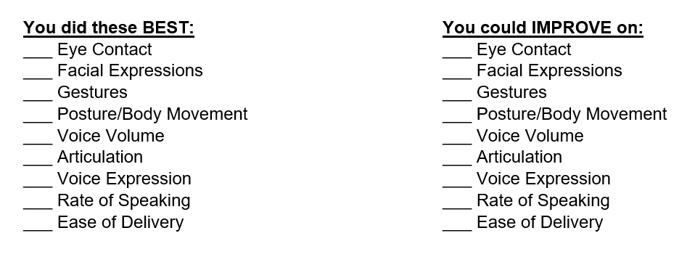

Student Name: _____________________________ Speech Time: ________

**Tropicana Speech Friendly Critique Sheet**

**The speech included:**

___ Catchy Introduction

___ Clear Message

___ Appropriate examples to reinforce message

___ Ideas that fit together with clear transitions

___ Something of interest to me

___ Memorable conclusion that repeated the most important part of the message 